File Permission:
Code:
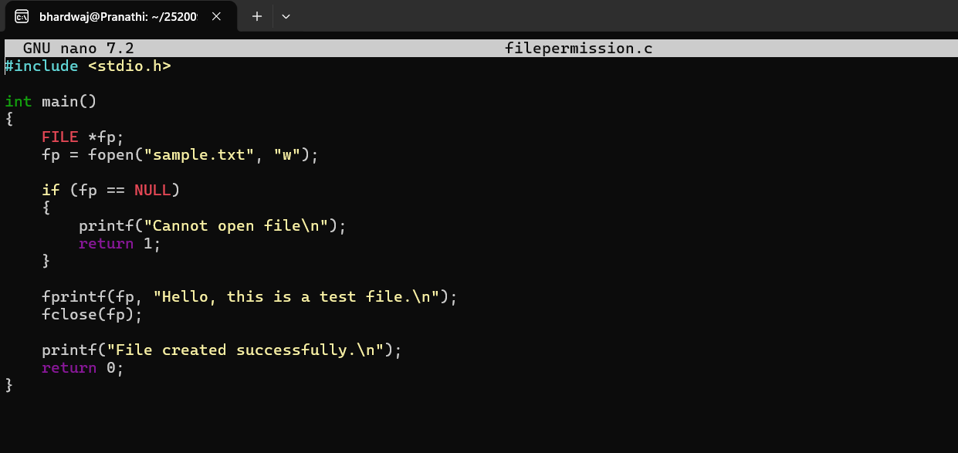
Output:
Check current file permissions: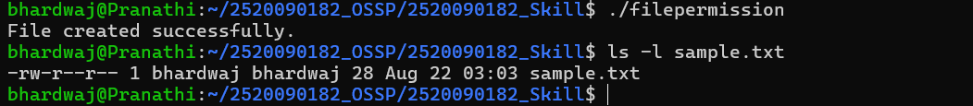Give Read + Write permission to everyone:
Permission commands using symbols:
Task of the Day — Permission Numbers:
1) Give Read and Write only to the owner
2) Give Read and Write to the owner and group
3) Only owner can read and write
4) Owner read/write, everyone else read-only
5) Owner can do everything, others can only read and execute
6) Owner and group can read/write
7) Only owner can execute
Fill in the permission numbers:

8) Owner: read + write; Group: nothing; Others: nothing
→ 600
9) Owner: read + write; Group: read; Others: read
→ 644
10) Owner: read + write + execute; Group: read + execute;
Others: read + execute
→ 755
11) Owner: read + write; Group: read + write; Others: nothing
→ 660
12) Everyone: read only
→ 444

